

***Azure DevOps Admin Handbook***

**<Version No. 1.3>**

|  |  |  |  |
| --- | --- | --- | --- |
| Document Revision History: | | | |
| Document Version Number | Document Revision Date | Written By | Change Summary  (Reference section[s] changed) |
| V1.0 | 6/24/2020 | Durga Navaneethan |  |
| V1.2 | 7/06/2020 | Durga Navaneethan |  |
|  |  |  |  |
|  |  |  |  |
|  |  |  |  |
|  |  |  |  |

Contents

**Pre-requisites -** 2

**Stage 1: Naming standard and folder structure** 2

**Stage 2: New Team Onboarding** 3

**Stage 3: Team Creation and Access** 3

**Stage 4: Repo and Branch creation** 4

**Stage 5 : Access Provisioning to Repo/Branch** 7

**Stage 6: Build pipeline** 11

**Stage 7: For Release pipeline** 14

**Stage 8: Steps to establish a new connection with Azure DevOps and create a new deployment group** 17

**Stage 9: Deployment group and Code repository folder structure in edge node** 18

**Stage 10: QA/PROD Deployment using release pipeline** 19

### 

## **Pre-requisites -**

### **Stage 1: Naming standard and folder structure**

Please refer the attached Excel sheet



### **Stage 2: New Team Onboarding**

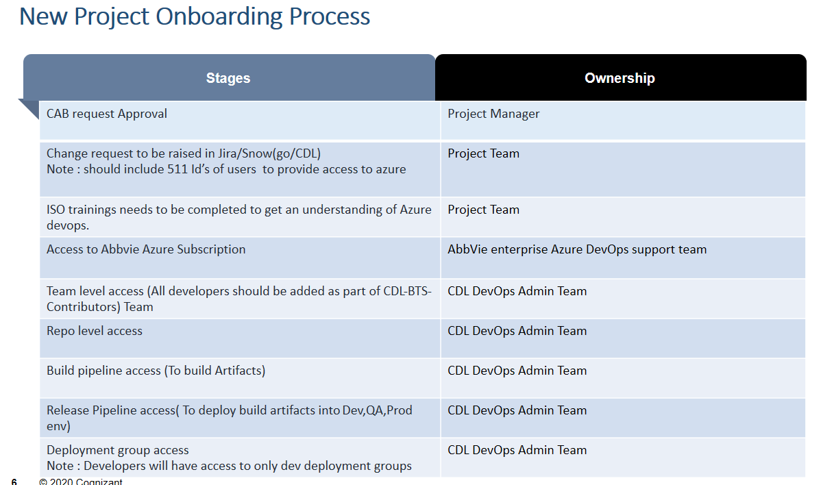

Note : Feature branch has to be created by admin team as part of onboarding process

### **Stage 3: Team Creation and Access**

* To Create a new team : Goto Project settings ->Teams->click on New Team

Note: For any new team creation we need to contact azure devops admin team (mavenwave team)

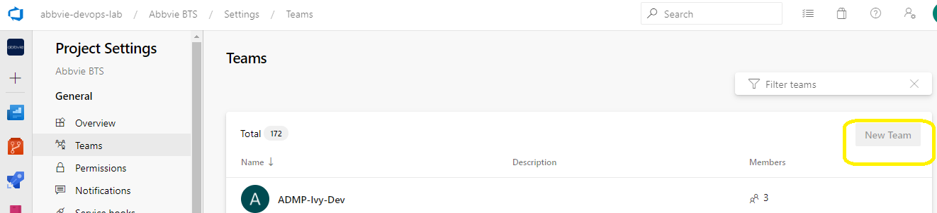

Teams we have so far :

1. CDL-BTS-ADMIN – Admin team
2. CDL-BTS-contributors – All developers
3. CDL-BTS-approvers – Who is responsible for code review and deployments
4. CDL-BTS-app-support –Ops team members

* To Add new members to existing team : : Goto Project settings ->Teams->search for team ->add

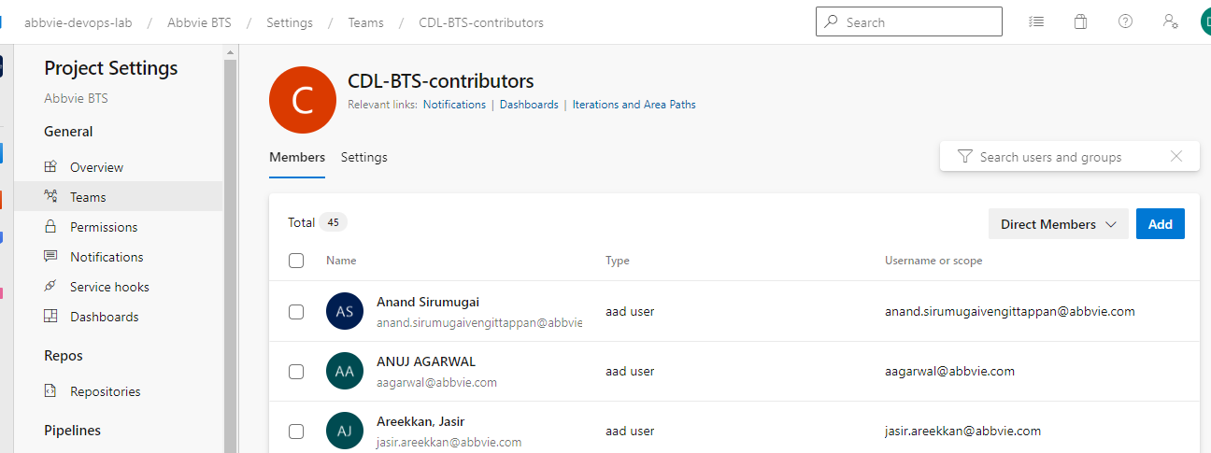

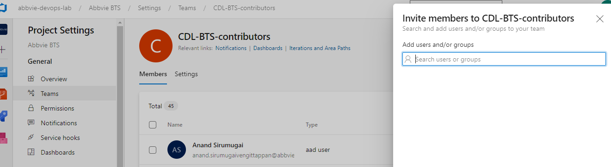

### **Stage 4: Repo and Branch creation**

1. Create Repo and different branches with specific folder structure based on the projects for ex : syndicated, marketing etc .

* Each repo should include Four different branches

1. feature branch(Ex: projectName_phase_ChangeRequestNumber)
2. develop
3. releaseV1.X( EX: ReleaseV1.0_ ChangeRequestNumber)
4. master

* Refer section “Stage 1: Naming standard and folder structure” for repo folder structure

**Steps to create repo and folder structure:**

1. Login to Azure devops “<https://dev.azure.com/>” using abbvie ID
2. Select Repos under abbvie BTS and click on “new repository from the drop down list “

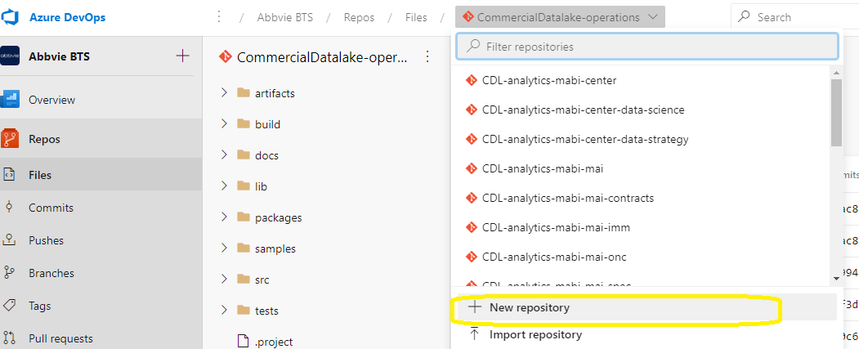

1. Enter and repository name and click on create (it creates new repository with Master branch as default)

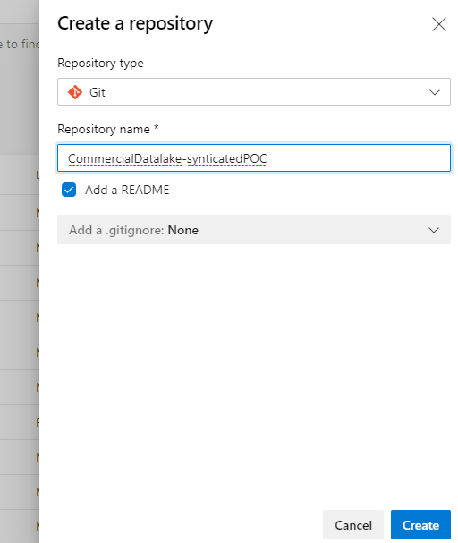

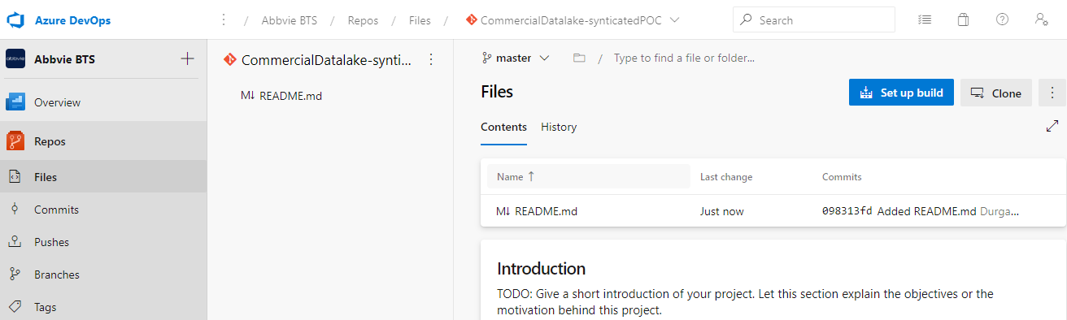

1. Select the drop down list from master branch and click on +new branch to create feature branch ,develop,release and master branch

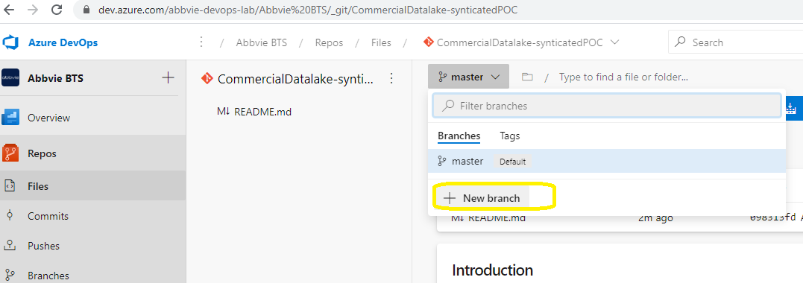

1. Provide branch name as develop/releasev1.X/master and create a new branch

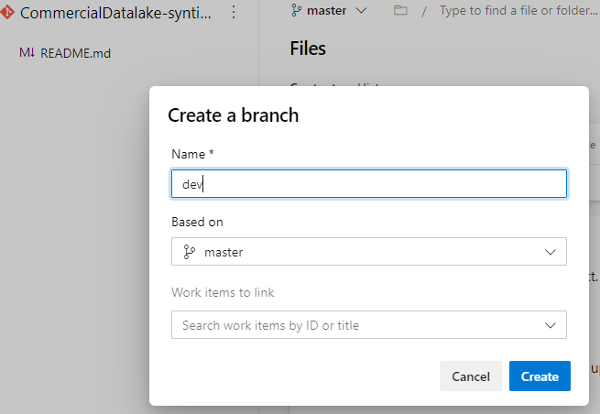

### **Stage 5 : Access Provisioning to Repo/Branch**

Make Develop as default Branch

* Ensure develop is configured as Default Branch

**Steps:**

1. Login to Azure devops “<https://dev.azure.com/>” using abbvie ID and select abbvie BTS
2. For every Repo we will have

* Feature branch
* Develop (Default Branch)
* Release branch
* Master

1. Select branch icon on the left hand side click on the three dots in develop branch and select “set as default branch “

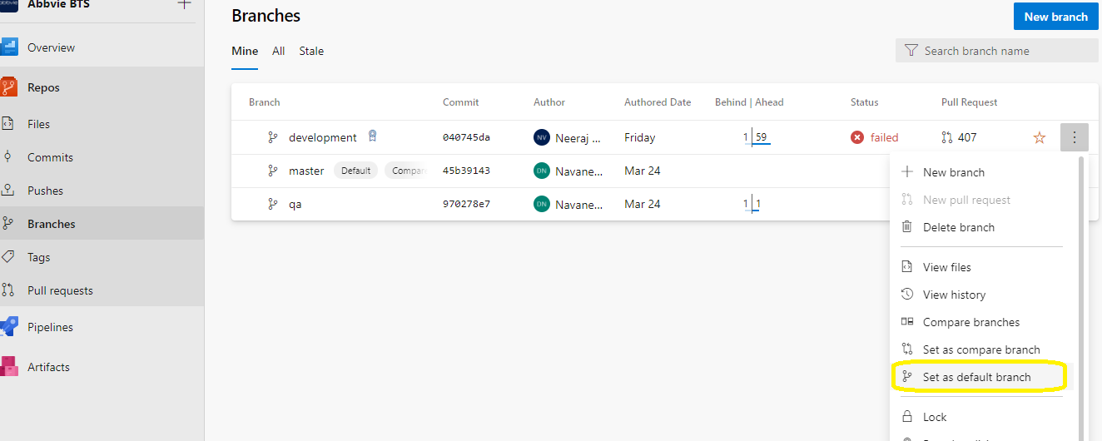

Repo level Permission

1. Select manage repository from the repo drop down list as below

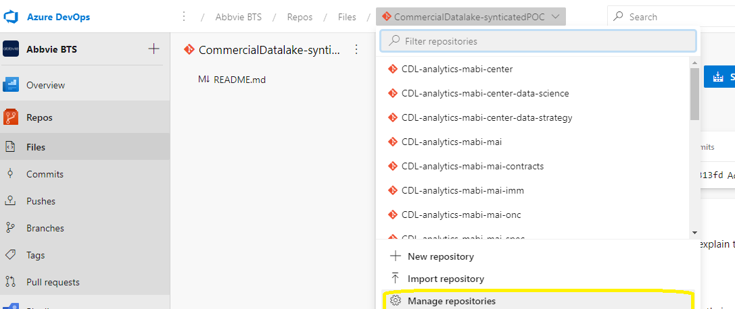

1. Select the respective repository and search for the “CDL-BTS-Admin” to add

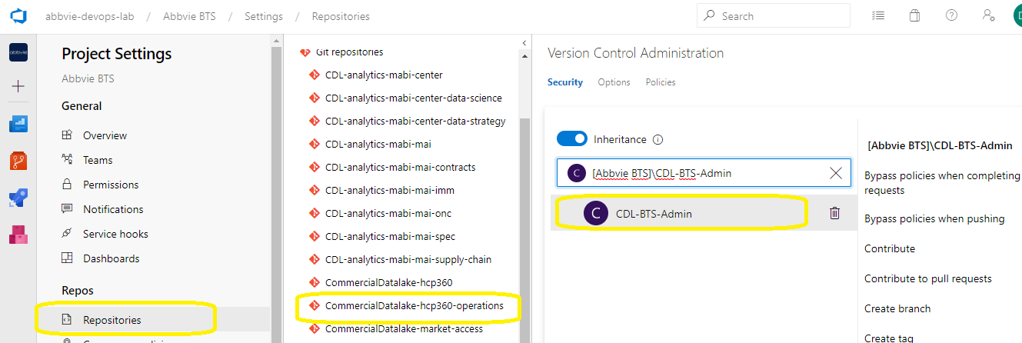

1. Provide permission as defined below

For CDL-BTS-Admin :

|  |  |
| --- | --- |
| **Bypass policies when completing pull requests** | Allow |
| **Bypass policies when pushing** | Allow |
| **Contribute** | Allow |
| **Contribute to pull requests** | Allow |
| **Create branch** | Allow |
| **Create tag** | Allow |
| **Delete repository** | Allow |
| **Edit policies** | Allow |
| **Force push (rewrite history, delete branches and tags)** | Allow |
| **Manage notes** | Allow |
| **Manage permissions** | Allow |
| **Read** | Allow |
| **Remove others' locks** | Allow |
| **Rename repository** | Allow |

Developers/Operations Team:

|  |  |
| --- | --- |
| **Bypass policies when completing pull requests** | Not Set |
| **Bypass policies when pushing** | Not Set |
| **Contribute** | Allow |
| **Contribute to pull requests** | Allow |
| **Create branch** | Not Set |
| **Create tag** | Not Set |
| **Delete repository** | Not Set |
| **Edit policies** | Not Set |
| **Force push (rewrite history, delete branches and tags)** | Not Set |
| **Manage notes** | Not Set |
| **Manage permissions** | Not Set |
| **Read** | Allow |
| **Remove others' locks** | Not Set |
| **Rename repository** | Not Set |

Branch level Permission

1. Go to newly created repo and select branches ,click on the three dots in dev and select branch security

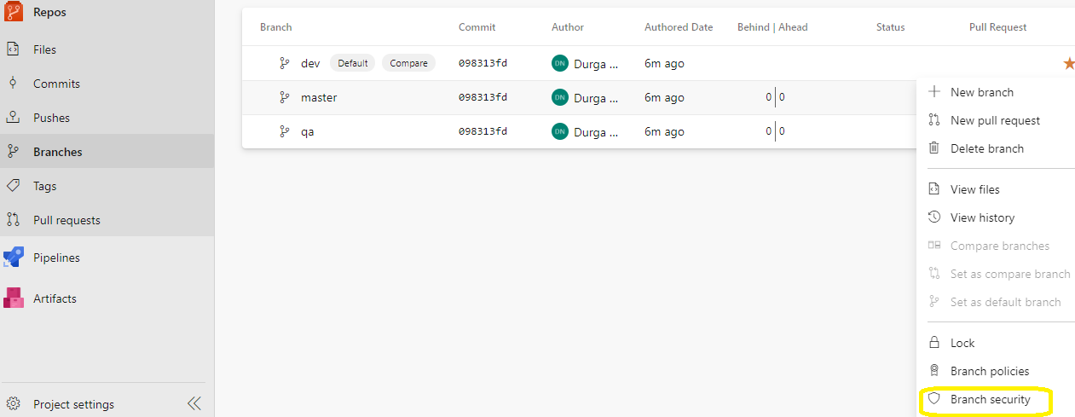

1. Ensure Dev and operations team has contribute access for all branches

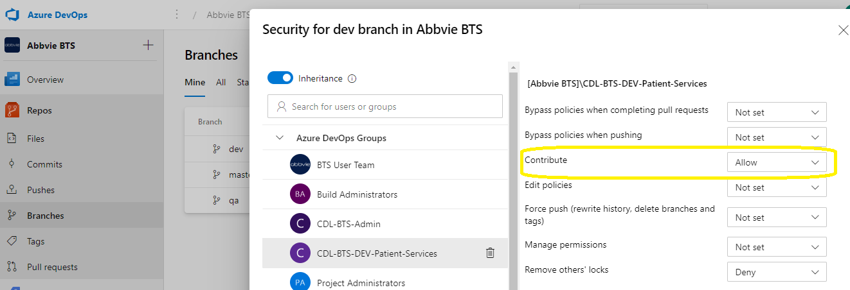

Branch Policy setup:

* Goto repo->branches -> develop/release/master->click on the 3 dots and select branch policies

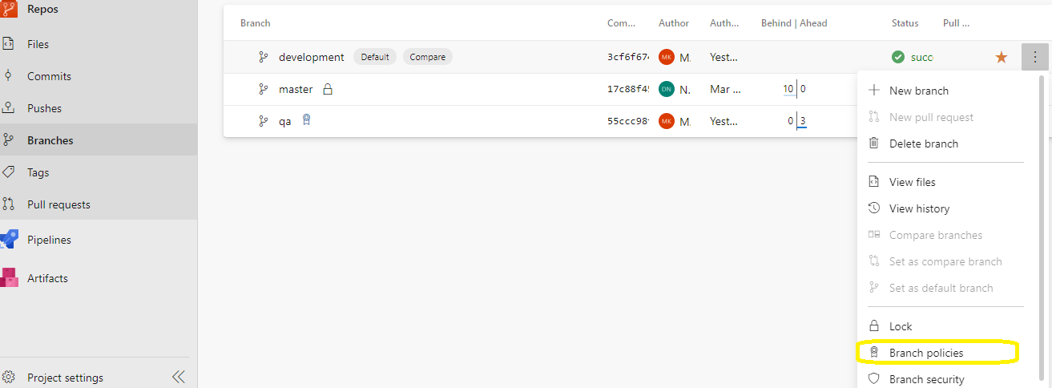

For Develop/release/Master:

Please set the minimum no of reviewers as 2 and select prohibit the most recent pusher from approving their own change as below,

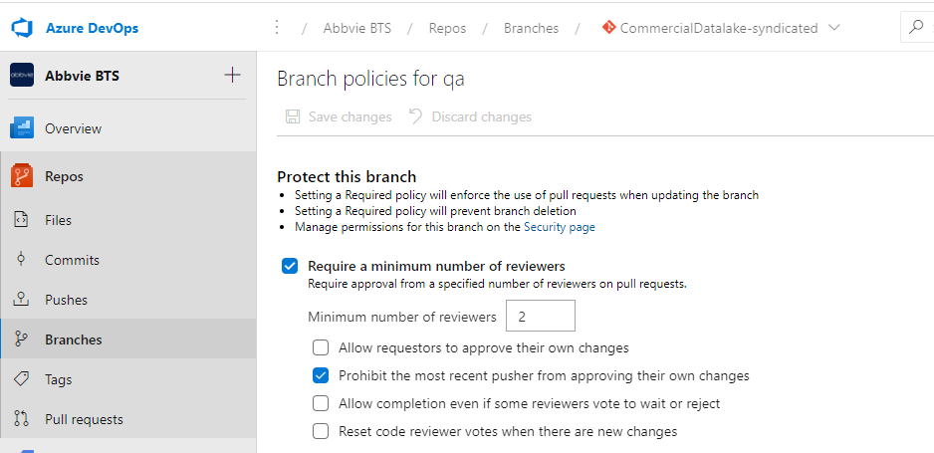

NOTE: For feature branch we don’t need to have any reviewers

### **Stage 6: Build pipeline**

How to create Build pipeline folder structure:

* Select pipelines under pipelines ->all->CDL
* Click on the three dots and select new folder to create folder structure for build pipeline

### 

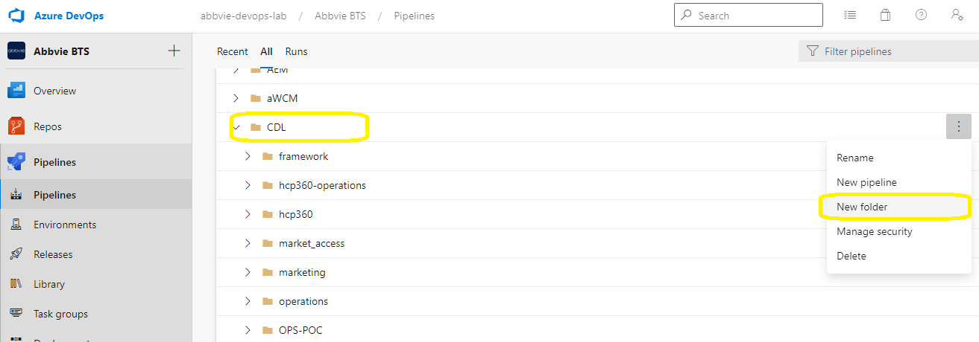

* Refer section “Stage 1: Naming standard and folder structure” for build pipeline folder structure as below

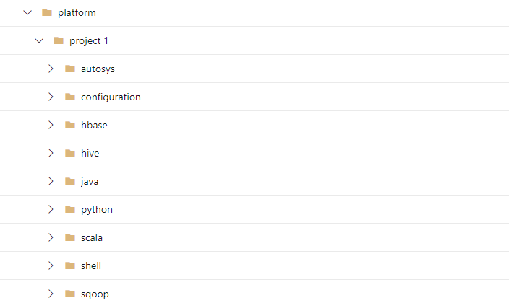

Access to Build Pipeline:

* Select pipelines under pipelines ->all->CDL->platform
* Select folder for which we need to provide access



* Click on the three dots and select manage security

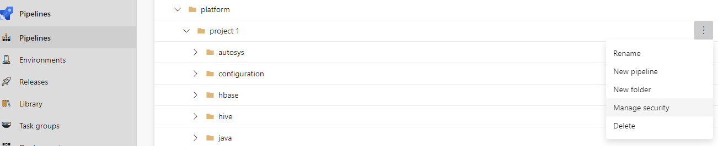

Provide access to the specific team as below ,

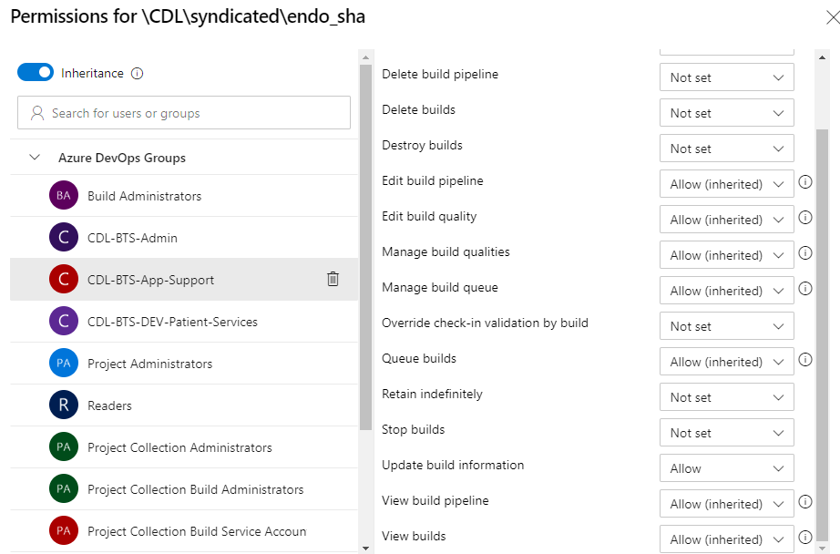

### **Stage 7: For Release pipeline**

How to create release folder

* Select pipelines->releases->CDL->click on new (to create a new folder) as below

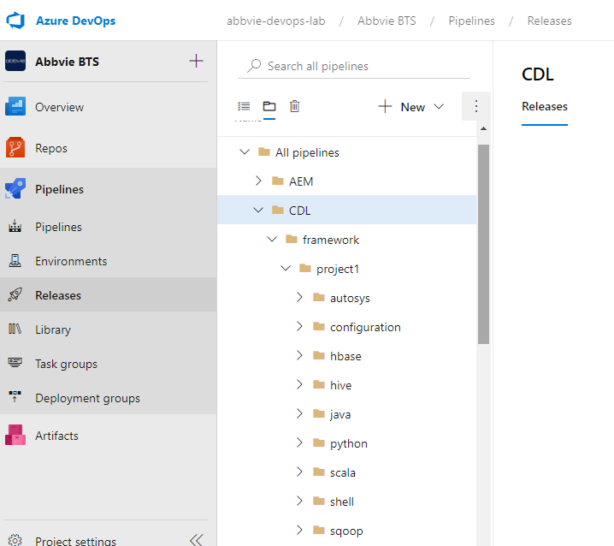

* Refer section Stage 1 - : Naming standard and folder structure” for release pipeline folder structure

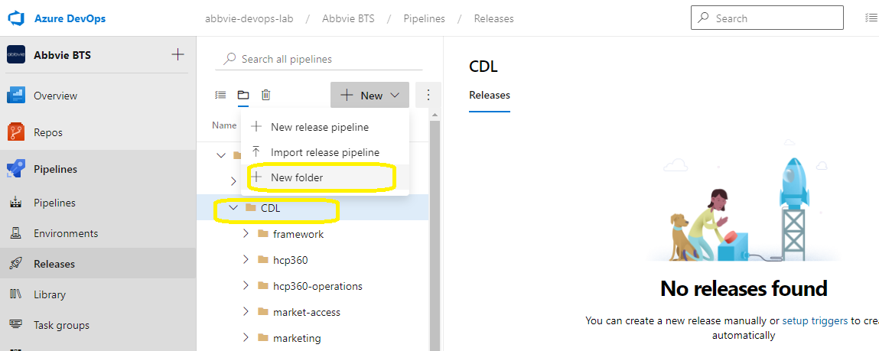

Access Provisioning:

* Select pipelines->releases->CDL->system name(syndicated)->select security

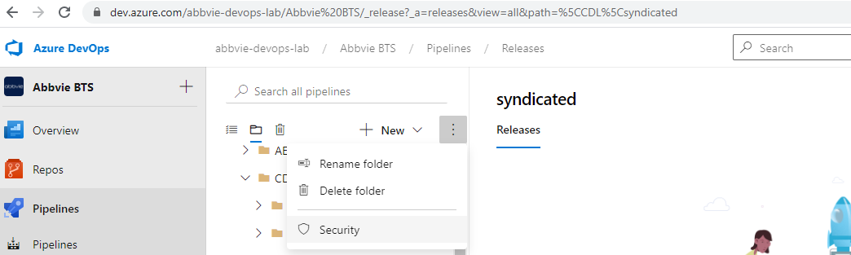

* Provide permission as below

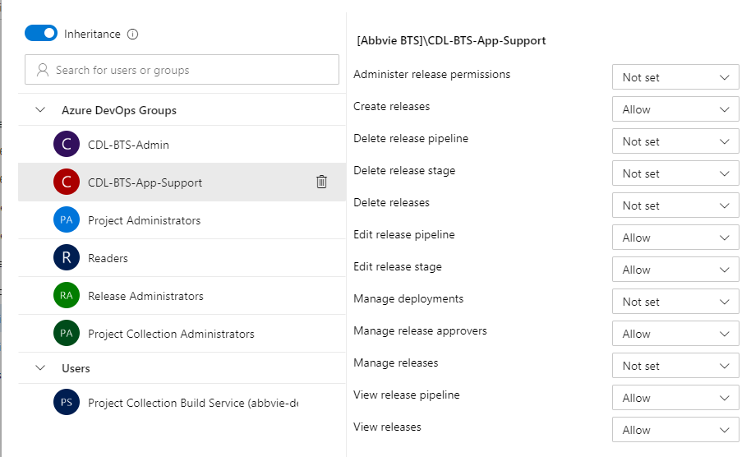

### **Stage 8: Steps to establish a new connection with Azure DevOps and create a new deployment group**

*#1. Login as local user created for the respective deployment group and download the necessary packages.*

Ex: su - locusr_azagent_cdl_platform_dev

$curl -fkSL -o vstsagent.tar.gz https://vstsagentpackage.azureedge.net/agent/2.168.2/vsts-agent-linux-x64-2.168.2.tar.gz;tar -zxvf vstsagent.tar.gz

*#2. Execute below to create new deployment group.*

$if [ -x "$(command -v systemctl)" ]; then ./config.sh --deploymentgroup --deploymentgroupname "CDL-PLATFORM-DEV" --acceptteeeula --agent $HOSTNAME --url https://dev.azure.com/abbvie-devops-lab/ --work _work --projectname 'Abbvie BTS' --auth PAT --token 6f3f75j52jp3ent3zpeekrflr6culgs5mmxy7xlud5hjld6v4ayq --runasservice; sudo ./svc.sh install; sudo ./svc.sh start; else ./config.sh --deploymentgroup --deploymentgroupname "CDL-PLATFORM-DEV" --acceptteeeula --agent $HOSTNAME --url https://dev.azure.com/abbvie-devops-lab/ --work _work --projectname 'Abbvie BTS' --auth PAT --token 6f3f75j52jp3ent3zpeekrflr6culgs5mmxy7xlud5hjld6v4ayq; ./run.sh; fi

*Note: This will fail since the script svc.sh is wrote to run as root or with any user which have sudo privilege. So, interrupt the execution.

*#3. Edit file "svc.sh" and search for run_as_user=${arg_2:-$SUDO_USER} and replace it with run_as_user=46321 and save the file.*

(Where 46321 is uid of the user locusr_azagent_cdl_platform_dev)

*#4. Still the script cannot be executed as the user locusr_azagent_cdl_platform_dev and will be expecting for root user.*

So as root user,

$cd /homes/locusr_azagent_cdl_platform_dev

$sh svc.sh install

$sh svc.sh start

### **Stage 9: Deployment group and Code repository folder structure in edge node**

* Select deployment groups under pipelines select dev deployment group and click on security

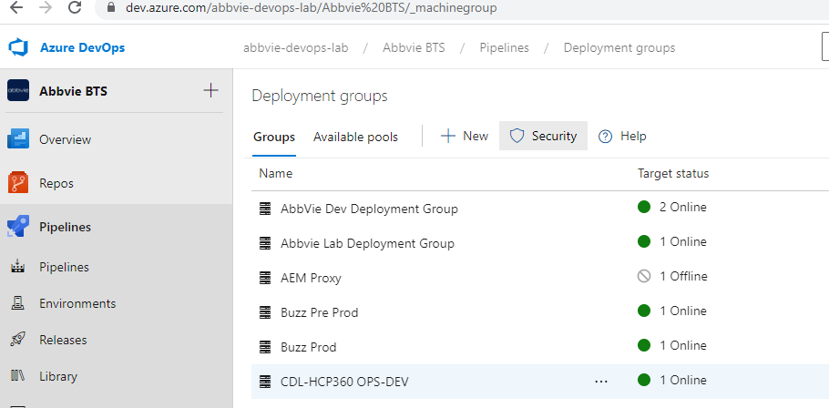

* Click on add and add the user group with user access

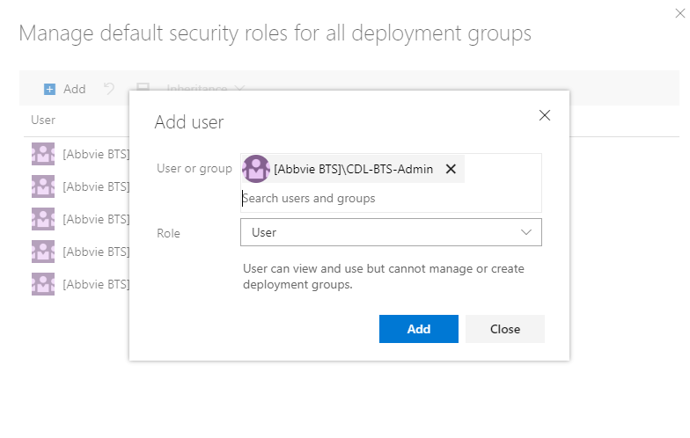

Note: For QA and prod environment development team will not have any access

Refer section Stage 1 - : Naming standard and folder structure” for edge node folder structure

### **Stage 10: QA/PROD Deployment using release pipeline**

* Select pipelines->releases->folder->CDL-><System>-

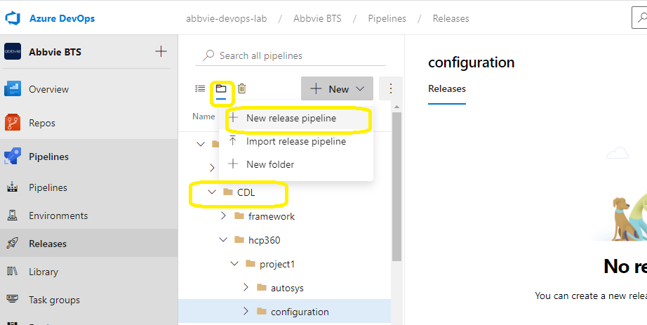

* Select the pipeline and click on edit

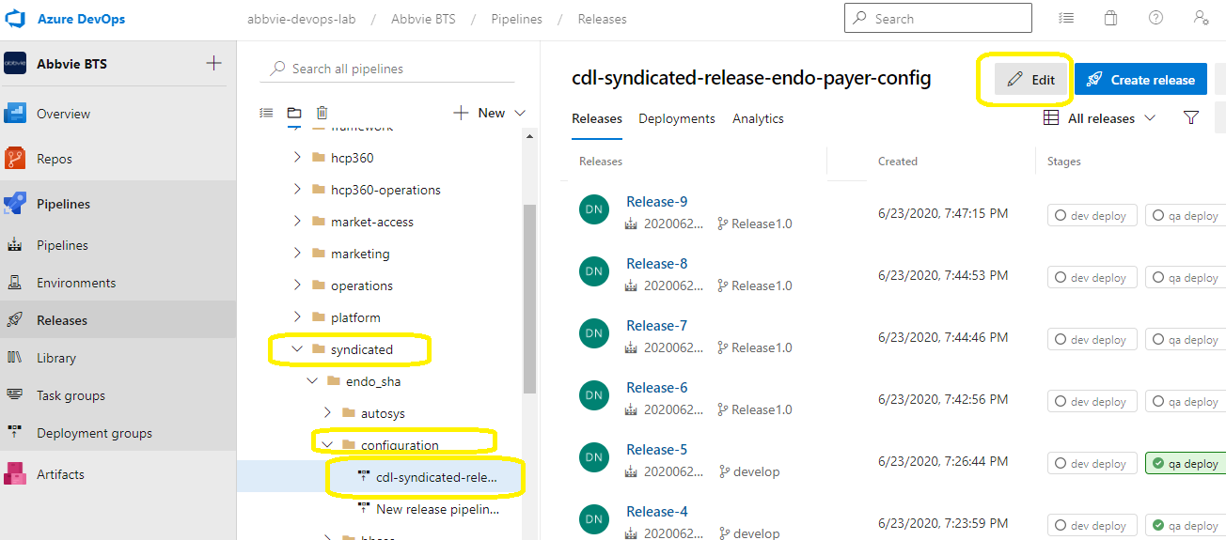

* Select QA deploy stage

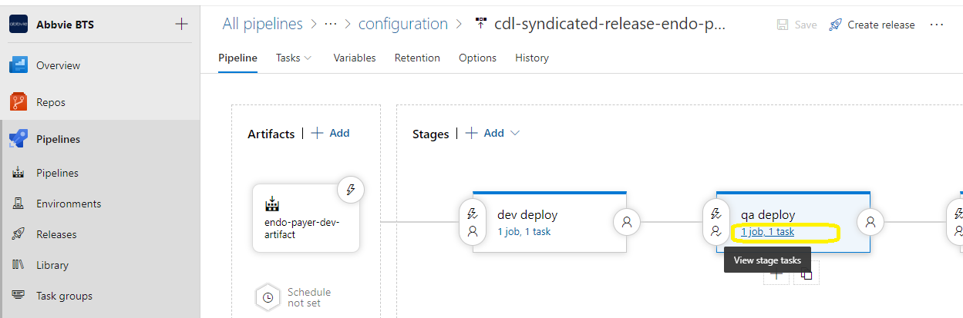

* Select QA deployment group and save

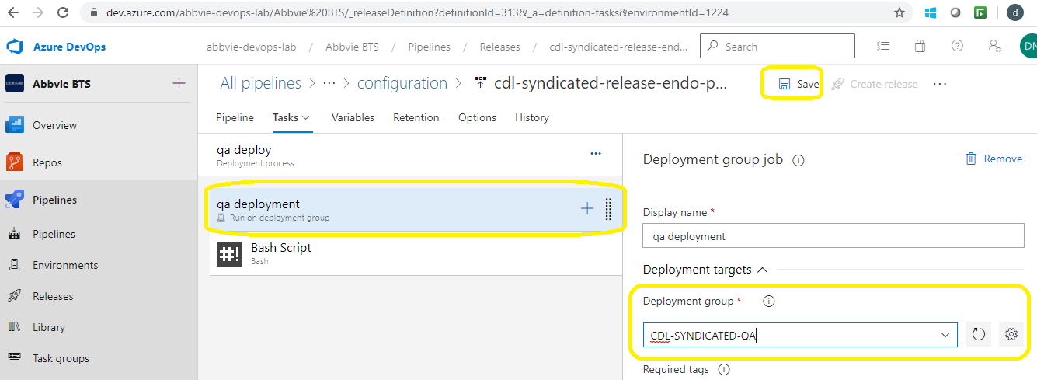

* In pre-deployment condition ensure CDL-BTS-approvers are added for deployment approval

And trigger create release

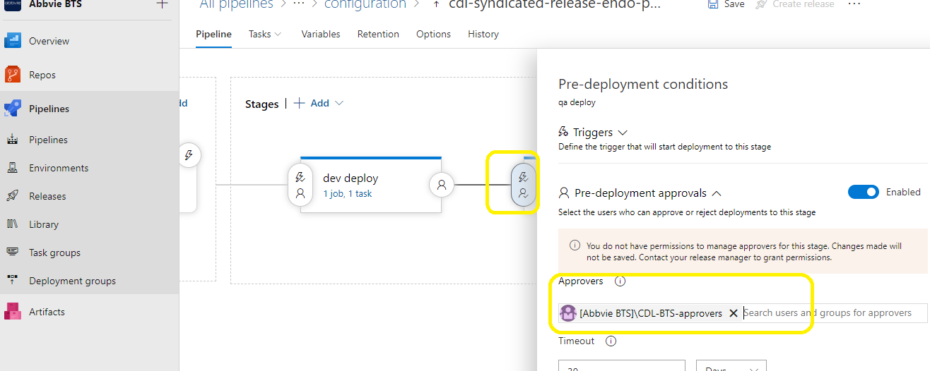

* Click on create release and select QA deploy for deployment

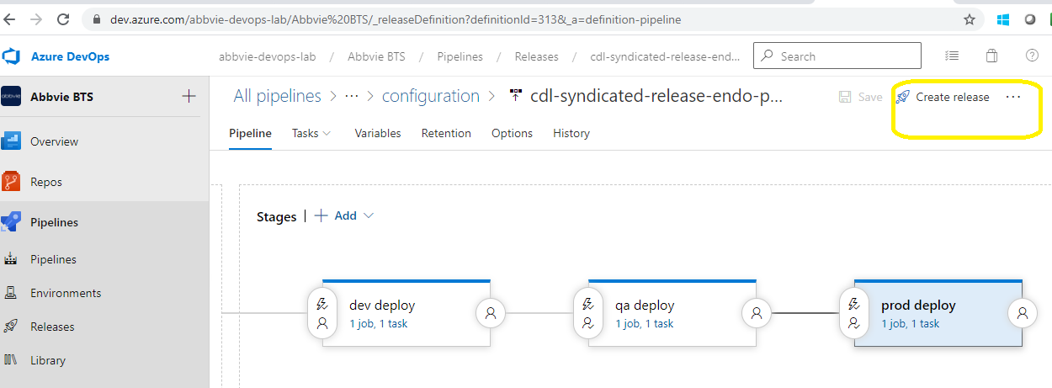

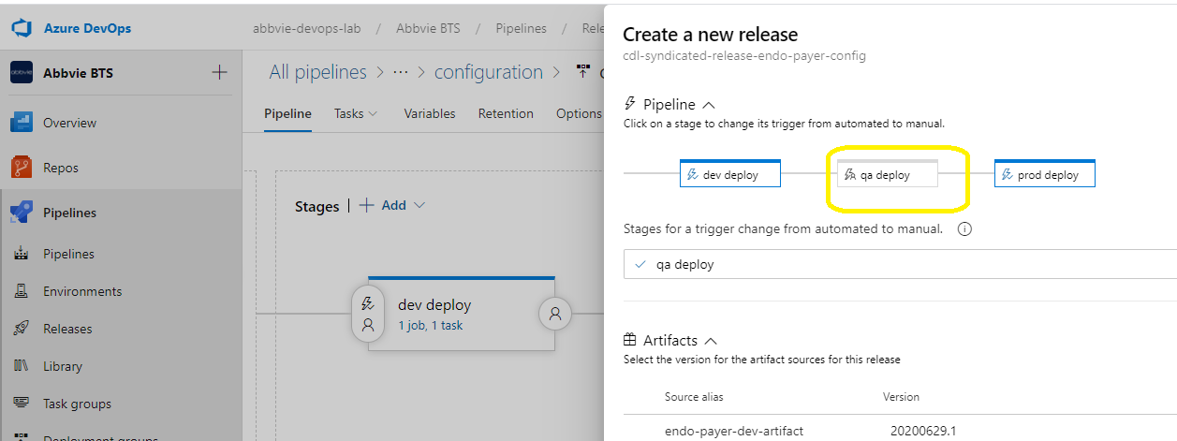

**For prod deployment:**

* Select pipelines->releases->folder->CDL-><System>-



* Select the pipeline and click on edit



* Select Prod deploy stage

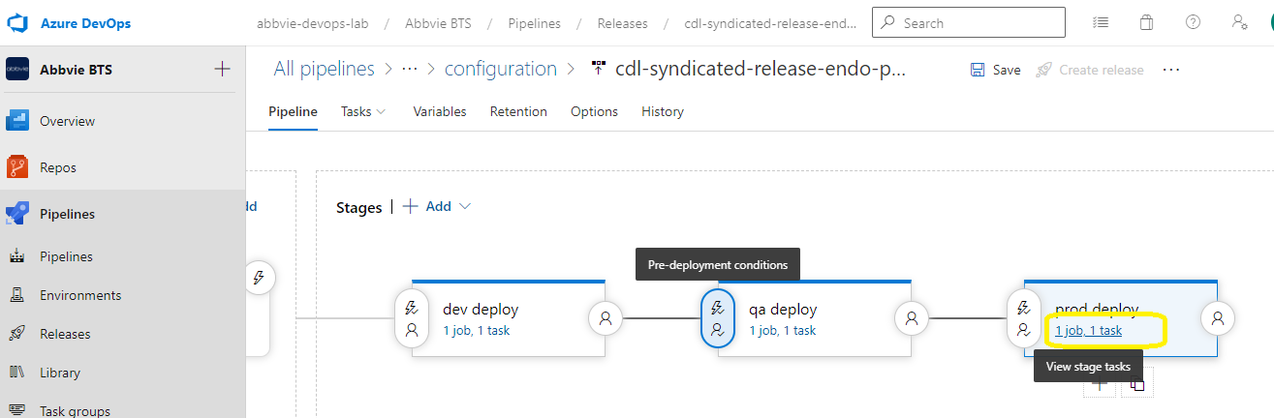

* Select Prod deployment group and save

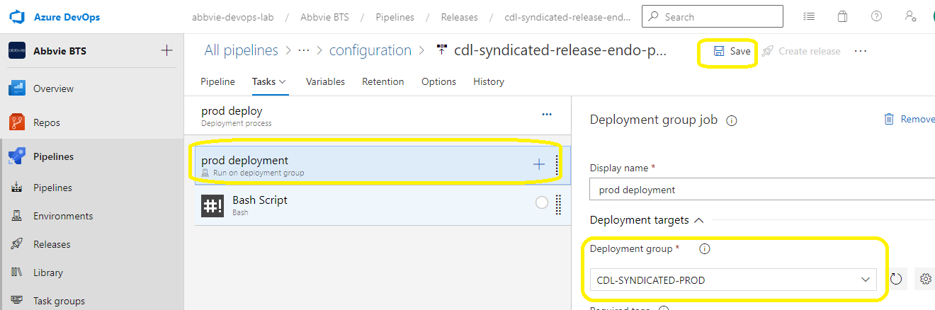

* In pre-deployment condition ensure CDL-BTS-approvers are added for deployment approval

And trigger create release

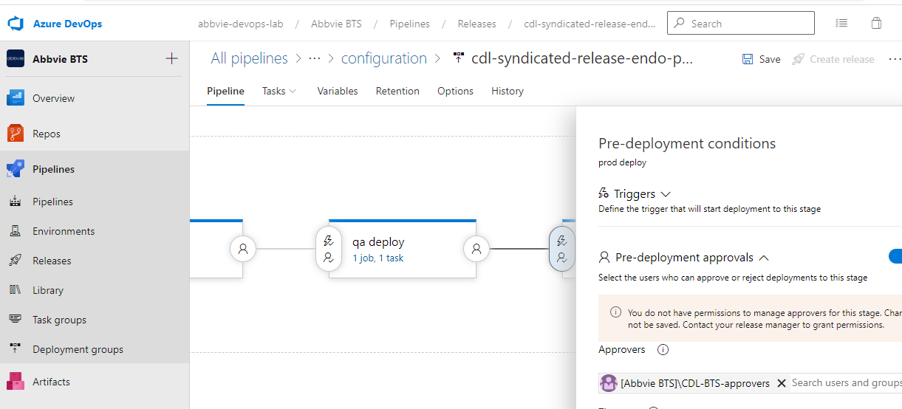

* Click on create release and select prod deploy for deployment



